Worksheet No 5: Information Transmission
Ancient methods of transmitting information

Identify the pictures in the boxes below. Then the correct name for each item and write in the box opposite use the following words

Beating drums | Fire lighting
Oral messengers
Making Representation | Oral- Town criers

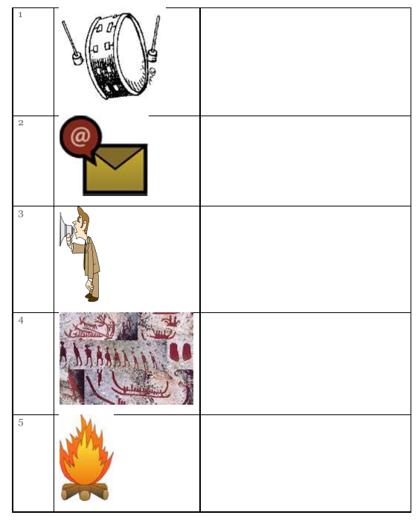

Problems of the ancient methods of transmitting data/information.

List four problems associated with the transmitting data/information.
1……………………………………………………………………………..
2……………………………………………………………………………..
3……………………………………………………………………………..
4……………………………………………………………………………..

